2017 MHS CHIEFS LIFT - A - THON
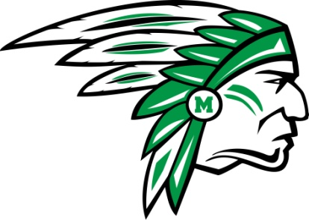
- The Lift - A – Thon Fundraiser is important and needs your complete cooperation to be successful.
- Each player is expected to participate. This is a team function and a team fundraiser, NOT PARTICIPATING is NOT AN OPTION.
- All players must raise a minimum of $100. Siblings are expected to raise $50 per athlete
- Make checks payable to the MCINTOSH TOUCHDOWN CLUB.
- IMPORTANT DATES
  - Begin seeking sponsors for donations / pledges on Monday March 6th.
  - We will test the 3 core lifts beginning Monday March 27th.
  - ALL donations / pledges from your sponsors are due on Friday April 14th.
- The money will be used for the following items:
  - General budget items.
  - New field equipment and weight room equipment.
  - Meals for the officials, press box officials and players (pre-game meals).
  - HUDL subscriptions, field fertilization, turf maintenance, ECHO renewal.
- Who can I seek for donations / pledges?
  - Family members, friends, neighbors, church members, friends and co-workers of parents, your doctor, your dentist, your youth football coaches, local businesses you frequent and your employer (if you work).
- Donations are a fixed amount given to you by your sponsor. Example: Mrs. Jones gives you $20 for participating in the Lift – A – Thon.
- Pledges are based on how much you lift. Example: Uncle Bill pledges 2₵ per pound. This would equal $14 if you lifted 700lbs.

WIN THE DAY

